**Self-Driven Car**

**Main Idea**

To make an application-based car which has its own brain to find best possible path to reach its destination.

**Abstract**

This is application where our car has its own brain and it is finding its own way to reach destination. Here we have used artificial intelligence and deep learning to give our car brain to tackle with real time obstacle. It can detect obstacle its path and find other fastest possible path which can help it reach its destination.

**Background Details**

It is like a game where we are providing rewards to our car for its sensibility. Which means that car is getting positive reward if take right path and reach the destination in less time. If it takes more time reward given to it is less and if car cover distance in less time, then it gets more reward. If we create some obstacle then our car will detect that change and if it got stuck with that obstacle then car will get negative reward. So, to get more reward our car will take another route. In this way our car is continuously struggling for increasing its reward and after several tries, car finds best possible path. All this is done by using artificial and deep learning.

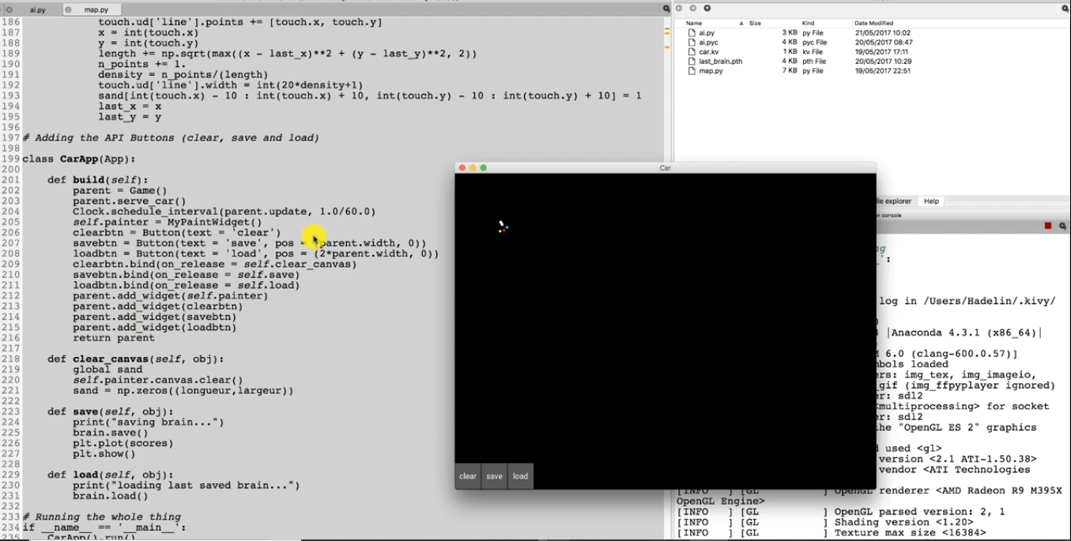

(Car Traveling from upper left corner to lower right corner)

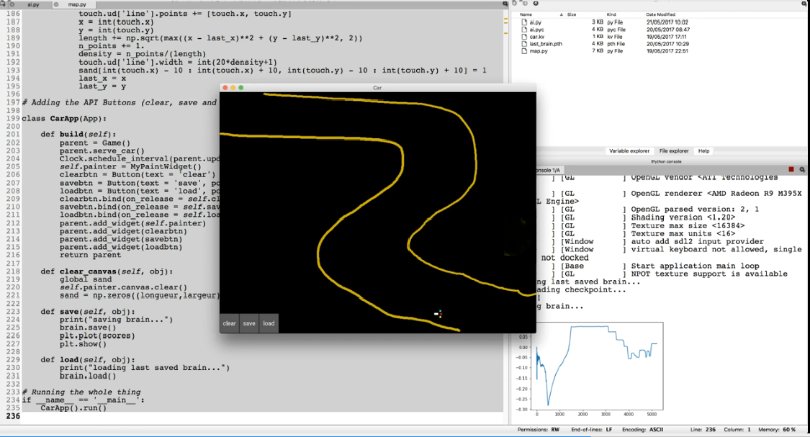

(Car Following specific path)

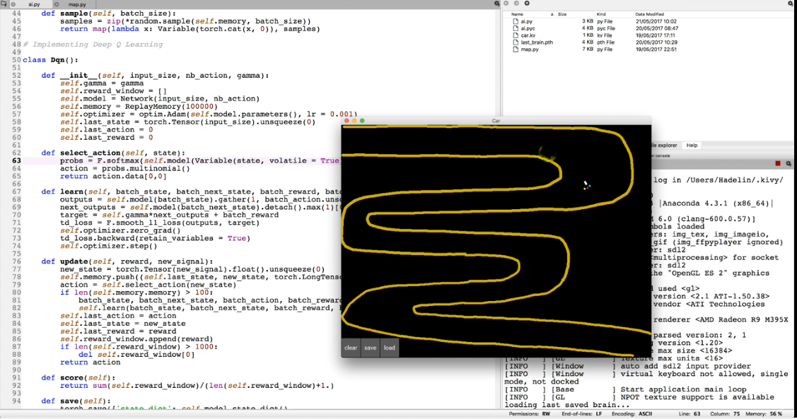

(Car following more path, learning and memorising the path)

**Details of Controls**

1. Clear: It is used to clear the canvas.

2. Save: To save the learn data. So, it can be used when application restarts.

3. Load: Loading the previously stored data on the canvas,

**Specification:**

Here, plot of reward car is getting is shown. So, performance of car be seen by observing graph. Here ups and downs show that car is learning its paths and flat part shows it completed learning and starts following that path.

**Details about source code:**

Written in python language using packages like:

1. Kivy
2. Pytorch
3. NumPy
4. Matplot

GitHub Details: <https://github.com/deepak1928?tab=repositories>

**Conclusion:**

I have created a running application of self-driven car which successfully reaches its destination in most efficient way possible.